Washington State Family to Family Health Information Center

Newsletter #1 – March 2021
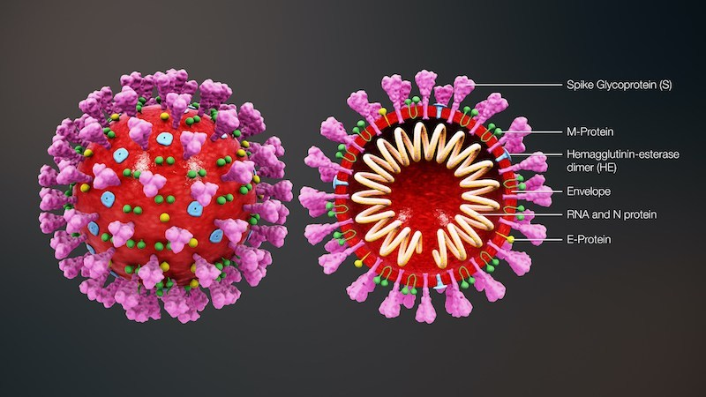
How the COVID mRNA Vaccines Works
This is the COVID virus. One of its main distinct features is the spike protein, which has a shape that is unique to this virus. It is this spike protein that catches on to a body cells receptor. This allows the COVID virus to infiltrate the cell and replicate. The immune system attacks the virus, but if COVID has already started replicating, the infection may prove fatal.
What the mRNA vaccines do, is to take just a section of the mRNA code of the COVID virus, specifically the one that makes the spike protein. When a vaccine of these little spike proteins is injected the spike proteins attach to the body cell receptors, just as they would if the full virus was there.
There is no full virus to infiltrate the human body cell and replicate, so when the body reacts to destroy the intruding virus, it's not at risk of failing. The immune system figures out how to identify and destroy the COVID virus by its spike proteins without putting people at risk of contracting COVID.
Both the Moderna and Pfizer vaccines are mRNA vaccines. Two shots taken a couple of weeks apart are necessary for it to be effective. The Johnson & Johnson vaccine is not a mRNA vaccine and works using uses viral vector technology.
March 2021 Calendar
Strategies for Supporting and Connecting with Your Teen – March 2nd 6:30-8:00
Telling Your Story with a Purpose Workshop – March 15th, 9:30-11:30
New Minor Guardianship Law Training – March 16th, 1:00-3:00
3rd Annual Washington Fatherhood Summit – March 16th-18th, 8:30-1:00 each day
Understanding Family Initiated Treatment (FIT) and Ricky's Law – March 31st, 2:00-5:00
Share Your Thoughts and Opinions on Health
The Health Resources and Services Administration (HRSA) is seeking English-speaking people living in rural areas to participate in virtual discussions about health. The purpose of these discussions is to obtain consumer feedback on newly developed health materials. HRSA is open to speaking with individuals from diverse backgrounds. Sessions will be held in March and May via Zoom and will last approximately 90 minutes. All who participate will receive monetary token of appreciation. If you or someone you know may be interested, please have them contact Heidi.Palacios@SchlesingerGroup.com or call (972) 503-3100 x- 407. Feedback from rural populations will help HRSA create easy to understand health materials for everyone. Response due by March 15th.

