Washington State Family to Family Health Information Center

Newsletter #8 – October 2021

COVID Booster Shots and Vaccinations for Children
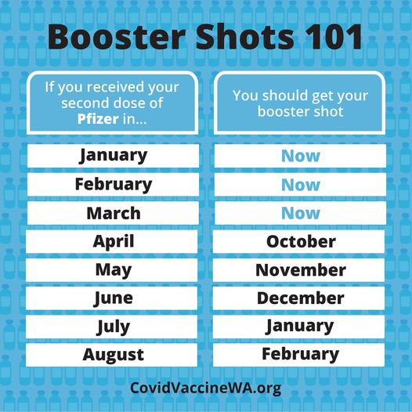
As the death toll from COVID-19 continues to increase due to the Delta variant, more vaccination options are being created. Booster shots of Pfizer for vulnerable populations have been passed by the FDA. Meanwhile, children aged 5-to-11 are likely to be eligible for vaccinations by the beginning of November.
A booster dose has been approved for recipients of the Pfizer/BioNTech vaccine, and is recommended for the following groups:
- People 65 years of age and older,
- People 18 years of age and older living in a long-term care setting, and
- People 50 – 64 years of age with underlying medical conditions or those at increased risk of social inequities.
A booster dose of Pfizer is also available to several other groups, including individuals who are 18-49 years of age with underlying medical conditions, and 18-64-year-olds who are at higher risk of COVID-19 exposure and transmission due to their occupational or institutional setting.
The Moderna vaccine, which uses the same mRNA technology as the Pfizer vaccine, has applied to the FDA for authorization to offer a booster shot. The Johnson & Johnson vaccine, which uses viral vector technology and was used by 15 million Americans, also will be reviewed for a booster dose. A decision on both vaccination boosters should be made by the end of October. Some doctors are suggesting that Johnson & Johnson vaccine recipients are the most vulnerable to falling immunity rates, and need the booster dose most urgently. Visit the Washington State department of Health page on COVID Booster Doses for more information.
COVID vaccinations for children aged 5-11 may be available as early as the beginning of November. Pfizer has submitted its data to the FDA for approval of their vaccine for children, which is set to be reviewed on October 26th. The vaccine has the same ingredients as the regular Pfizer/BioNTech vaccination but is 1/3 the strength of the teen dose – 10 micrograms per injection vs. 30-microgram for people 16 to 25 years old.
It is currently estimated that around half of U.S. children, aged 12-17, have had at least one does of COVID 19 Vaccine. Some polls show that parents of younger children may be less inclined to have their child be vaccinated. Pfizer is currently undergoing trials on a COVID vaccine for 2-to-4-year-olds, but it will not be available until 2022.

October 2021 Calendar
All events are free and on-line
Special Education: 10 Tips for Advocating for Your Child – October 5th
Sharing Down Syndrome in Pierce County – October 8th
Creating Connections: Supported Decision Making – October 10th
Pediatric Complex Care Seminar: Irritability and Pain – October 14th
Pierce County P2P Awesome Autism Family and Parent Group – October 14th
The Future Looks Bright – October 16th
The Epidemic of Sexual Minority Depression – October 21st
Fall Social: Humor and Laughter – October 23rd
PTI Training for ESD 114 – October 27th

